November 24th 2014
IPSO Day at the Peruvian Psychoanalytic Society (SPP) and participation of Peruvian candidates at the Winnicott Encounter.

Aura Lorenzo visited the candidates of the Peruvian Society of Psychoanalysis (SPP). Lima, Peru is a beautiful city and the people were so nice and kind, that we would like to pay thanks to Maria Julia Ardito, president of the Peruvian candidate´s association for the organization and generosity in all the academic and social activities, to Johanna Mendoza and her family also for their generosity and hospitality, and to Giannina Paredes, Eduardo Llanos, Amelia Casas, Maricarmen Bello, Pilar, etc. for their time; to the president of the Peruvian Society, Eduardo Gastelumendi thank you very much for the welcome and the support on organizing the IPSO Study day and to all the candidates, for their warm welcome and the social activities that they organized to be together.
The subject of the IPSO day had the objective to show with real examples, how the tools that IPSO provided to candidates, could be used by them:
The Visit Candidate Program (VCP): Eduardo Llanos (advanced candidate), mentioned that he had a wonderful experience in Madrid when he visited to APM (Asociación Psicoanalítica de Madrid); unfortunately the activity did not have enough time; then for more information, please go to our IPSO web page, and read his report (VCP).
Two days before, the “XXIII Encounter of Donald W. Winnicott´s thought: “The transitionnality: The Necessary Size of the Absence”, had taken place; was the the IPSO Study Day, the presentation of the paper: “The self from Winnicott to Christopher Bollas” by Aura Lorenzo, was the framework for introducing the Study groups, another tool that is very useful for candidates to get a profound knowledge of an author. Other social activities were shared amongst IPSO candidates like lunch. Eduardo Llanos has some artworks in important museums in Lima, Peru, he was very kind for inviting us to his house; it looked like an art gallery. We had the opportunity to see Amelia Casas again, our last IPSO´s treasurer who was kind enough to welcome us to her house.

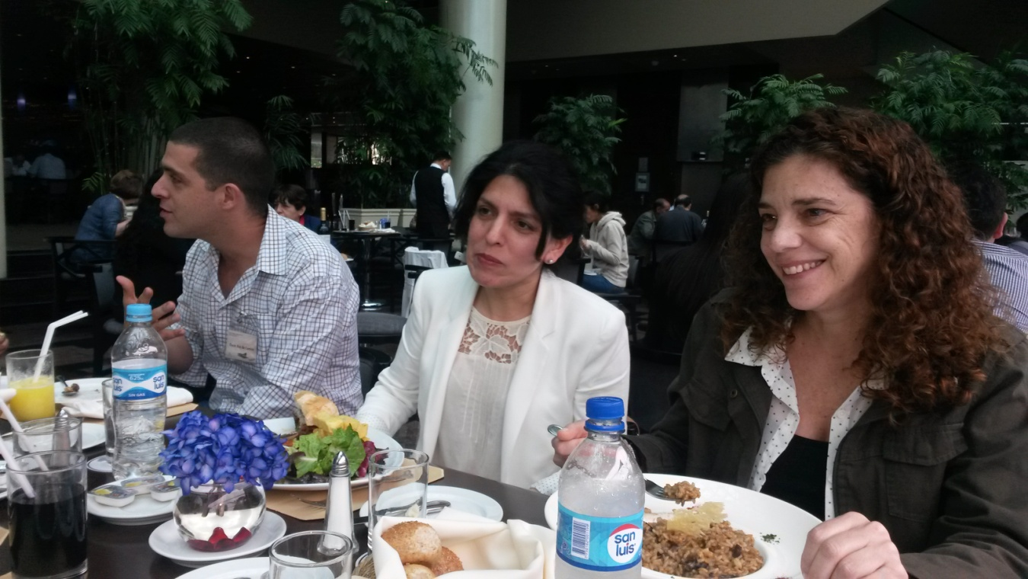
(IPSO candidates from the Peruvian Psychoanalytic Society:Oscar Rey de Castro, Maricarmen Bello)

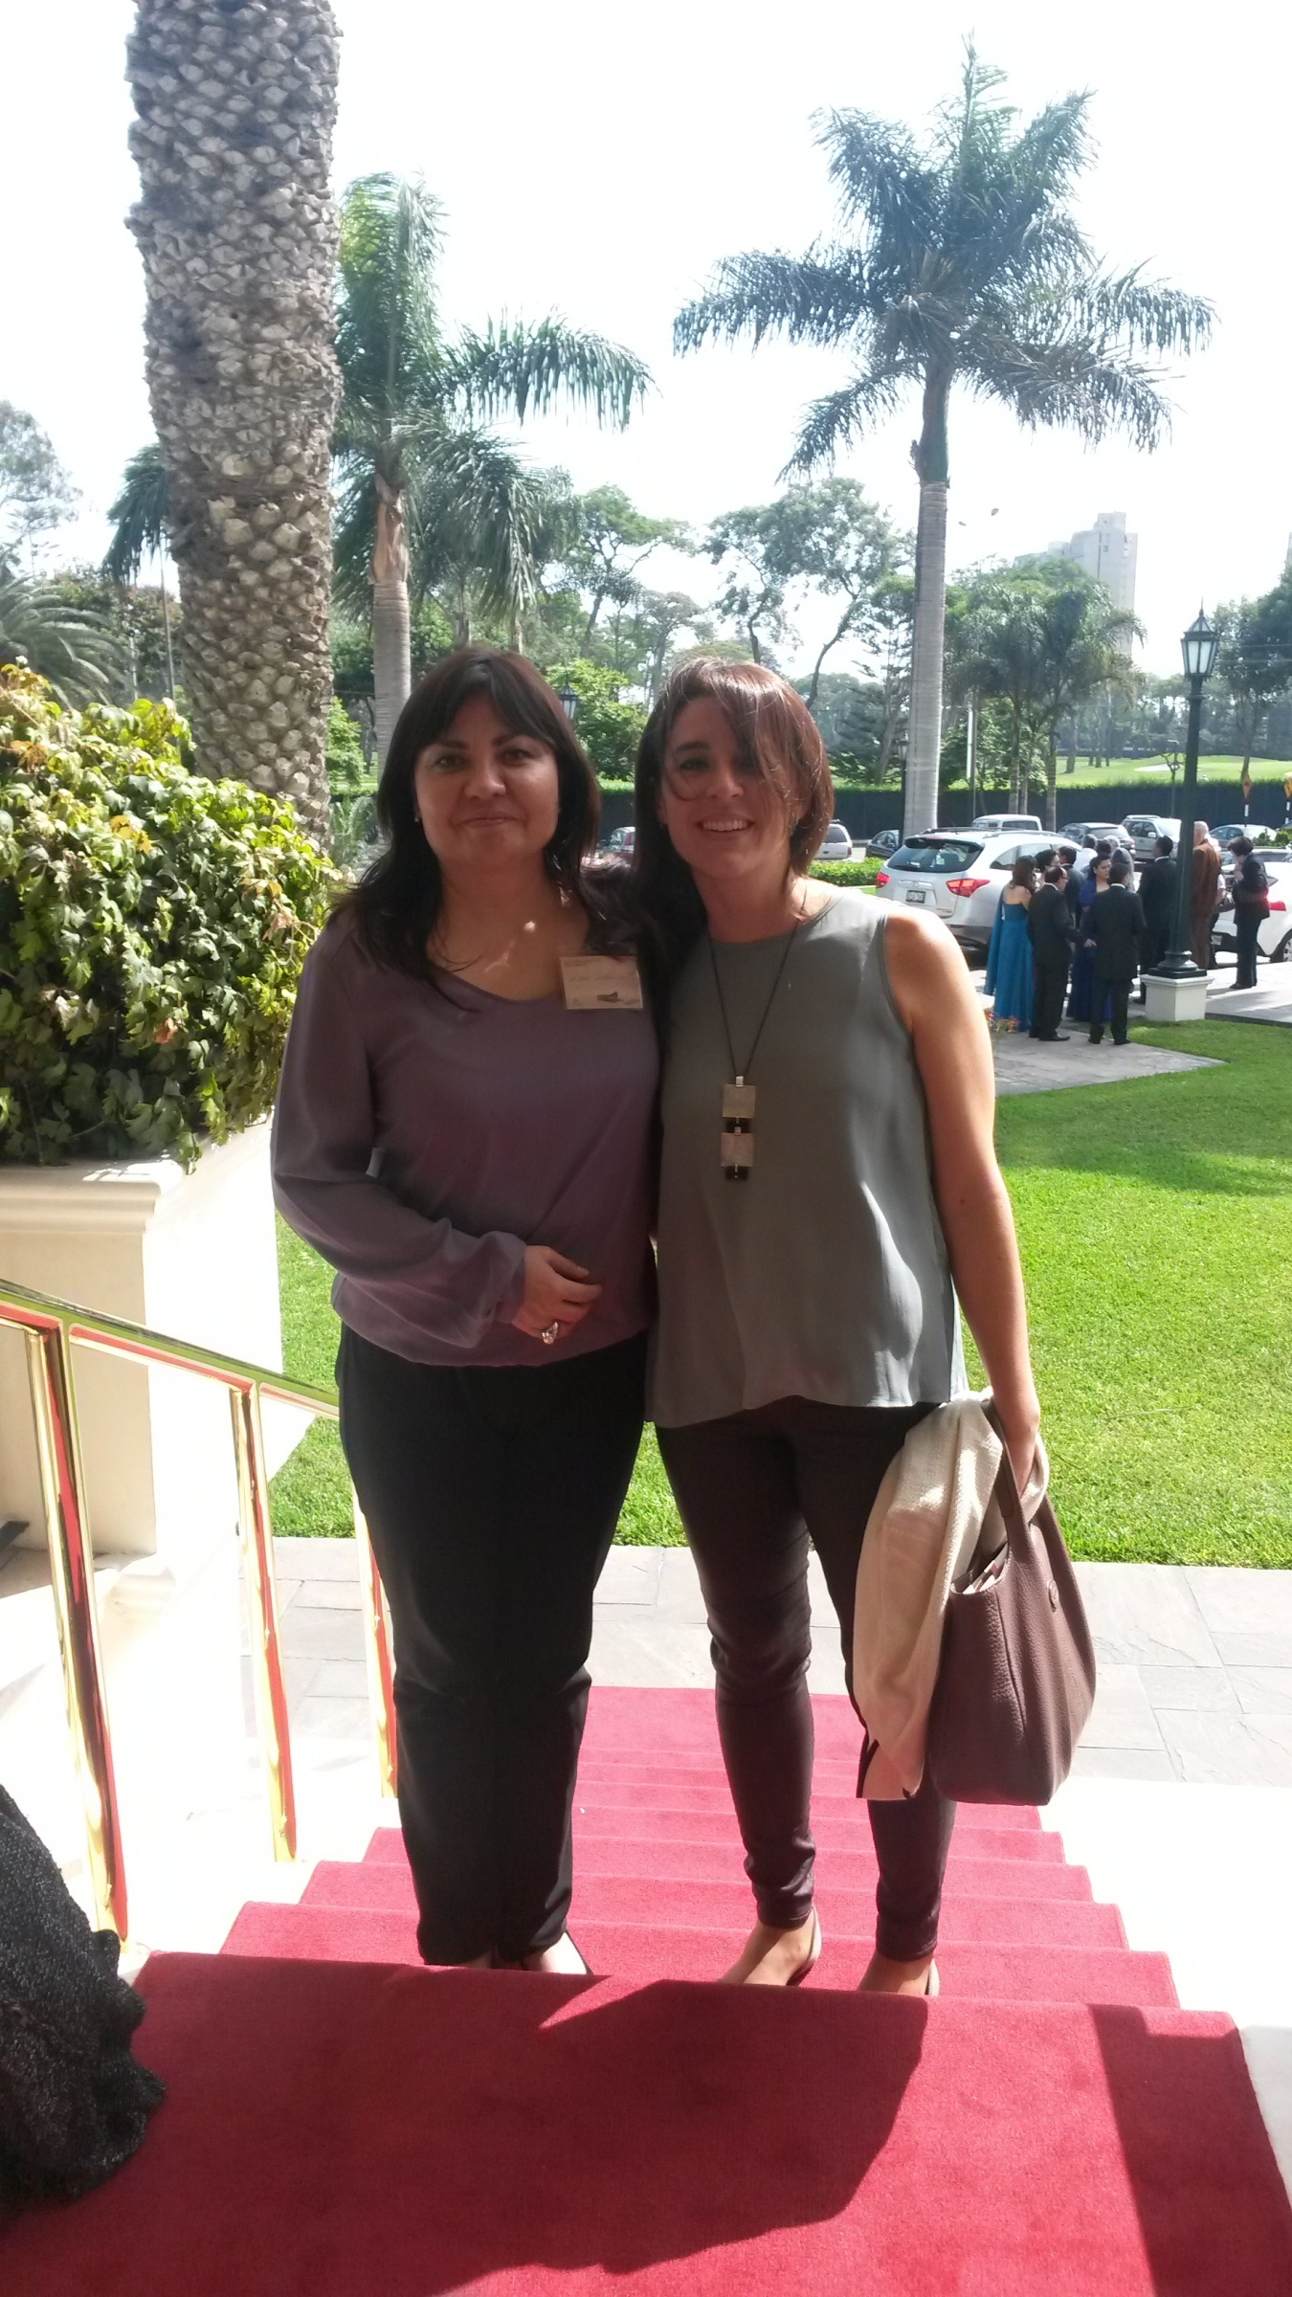
Aura Lorenzo and Carmen María Valdez

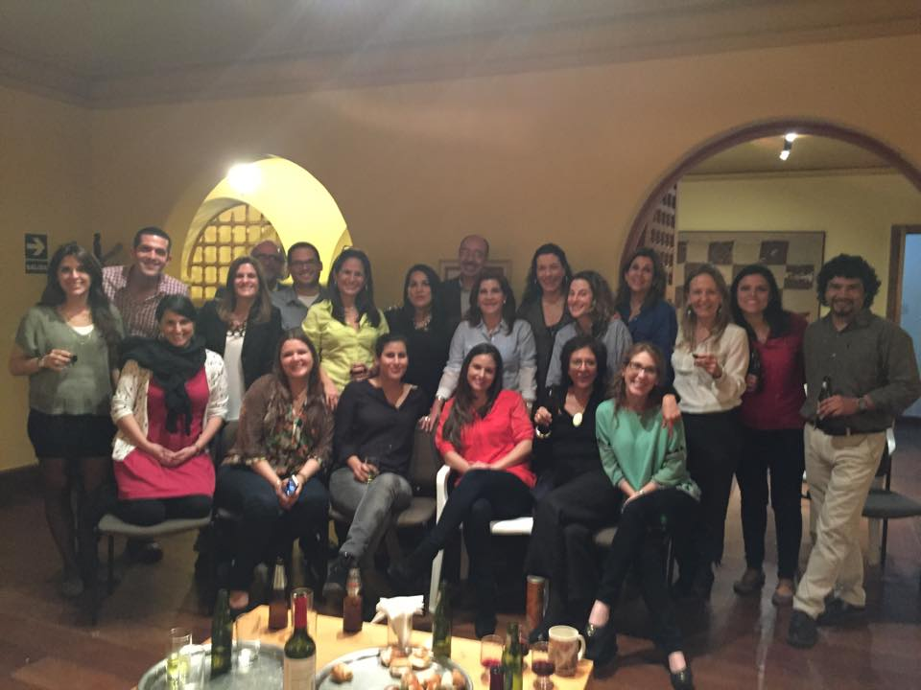

Candidates from Peruvian Society of Psychoanalysis: Oscar Rey De Castro, Alejandra Caravedo, Raul Fatule Canella,
Zarela Zariquiey, Betty Carreño,Carla Peralta, Carla Marcos, Eduardo Llanos, Sharon Drassinower, Johanna Mendoza,
Vivian Schwartzman, Maria Julia Ardito, Giannina Paredes, Meche Valdez, and ….

